# Project Design Phase-II Technology Stack (Architecture & Stack)

|  |  |
| --- | --- |
| Date | 19 October 2022 |
| Team ID | PNT2022TMID49894 |
| Project Name | Web Phishing Detection |

Technical Architecture:

# Example: Predictive Analysis for Web Phishing using machine learning

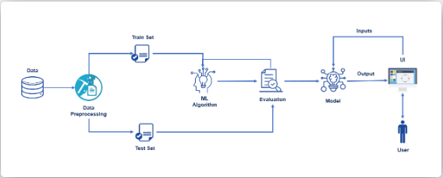

Table-1 : Components & Technologies:

|  |  |  |  |
| --- | --- | --- | --- |
| **S.No** | **Component** | **Description** | **Technology** |
| 1. | User Interface | user interacts with application  e.g. Mobile App, web application. | Python |
| 2. | Application Logic-1 | Developing application. | Python |
| 3. | Application Logic-2 | To add the Phishing website URL(data). | IBM Watson STT service |
| 4. | Application Logic-3 | To detect the Harmful URL. | IBM Watson Assistant |
| 5. | Database | To create data base. | MySQL, NoSQL, etc. |

|  |  |  |  |
| --- | --- | --- | --- |
| 6. | Cloud Database | Database Service on Cloud. | IBM Cloud etc. |
| 7. | File Storage | Storing data. | IBM Block Storage or Other Storage Service or Local  Filesystem |
| 8. | External API-1 | To deliver accurate and precious data. | IBM Weather API |
| 9. | External API-2 | To verify data. | Correct URL |
| 10. | Machine Learning Model | To identify and locate URL. | URL Recognition Model |
| 11. | Infrastructure (Server / Cloud) | To compile and run the apps locally. | Local, Cloud Foundry, etc. |

Table-2: Application Characteristics:

|  |  |  |  |
| --- | --- | --- | --- |
| **S.No** | **Characteristics** | **Description** | **Technology** |
| 1. | Open-Source Frameworks | Demonstrate how to combine realtime Website URL data with analytics to create a solution for predictive analysis of phishing website. | Node RED |
| 2. | Security Implementations | Advanced method by Naïve based algorithm and Random forest. | Encryption |
| 3. | Scalable Architecture | The user can access the safe URL by for their protection. | Automated  bootstrapping |
| 4. | Availability | Increase the availability. | Cloud computing |
| 5. | Performance | High performance. | Adaptive Contention  Window |